**CLINCH YOUR PLACE**

ABSTRACT:

Clinch your place is a very helpful android application for students and faculty members to analyze placement details and for students to get equipped themselves with the questions which they would be facing during their interviews.

OBJECTIVES:

* Providing details about companies and job domain .
* Feedback of companies are used to know about company’s demand.
* Experience of the candidates are used to understand the employability procedures.
* CGPA based analysis are done.
* Skill based analysis can be done to select the appropriate company.
* Company domain and demand is used to identify your dream company.
* The latest news of companies is displayed to prepare for interview.

TOOLS USED:

Front end:

* Bootstrap
* Html5
* Css
* javascript

Back end:

* Php
* Xampp

DESIGN DIAGRAMS:

Usecase diagram:

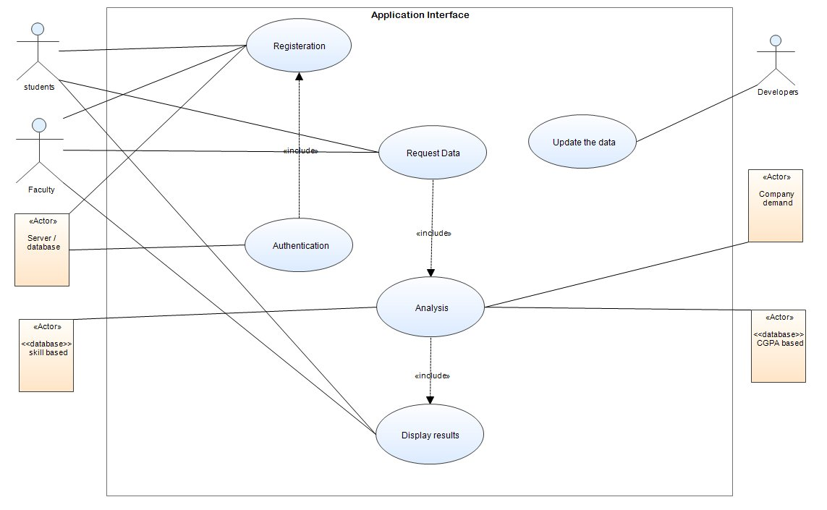

Data flow diagram:

LEVEL 0 :

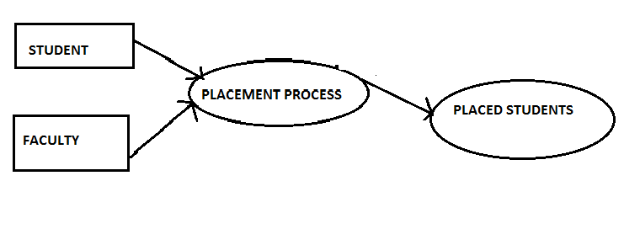

LEVEL1:

User interface:

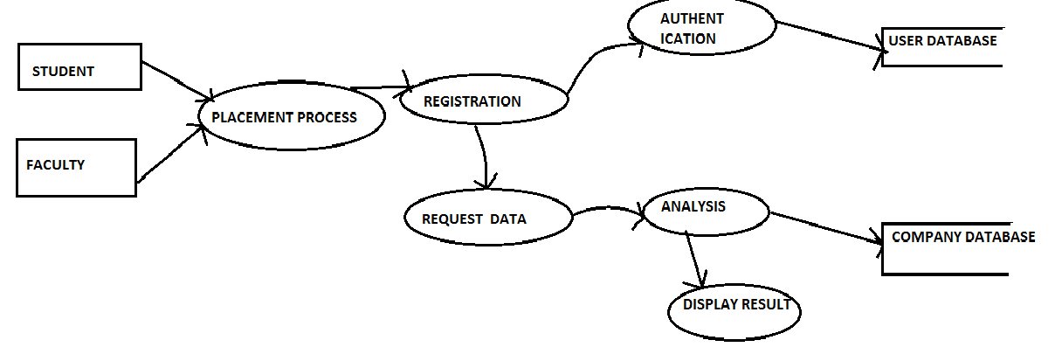

Registration:

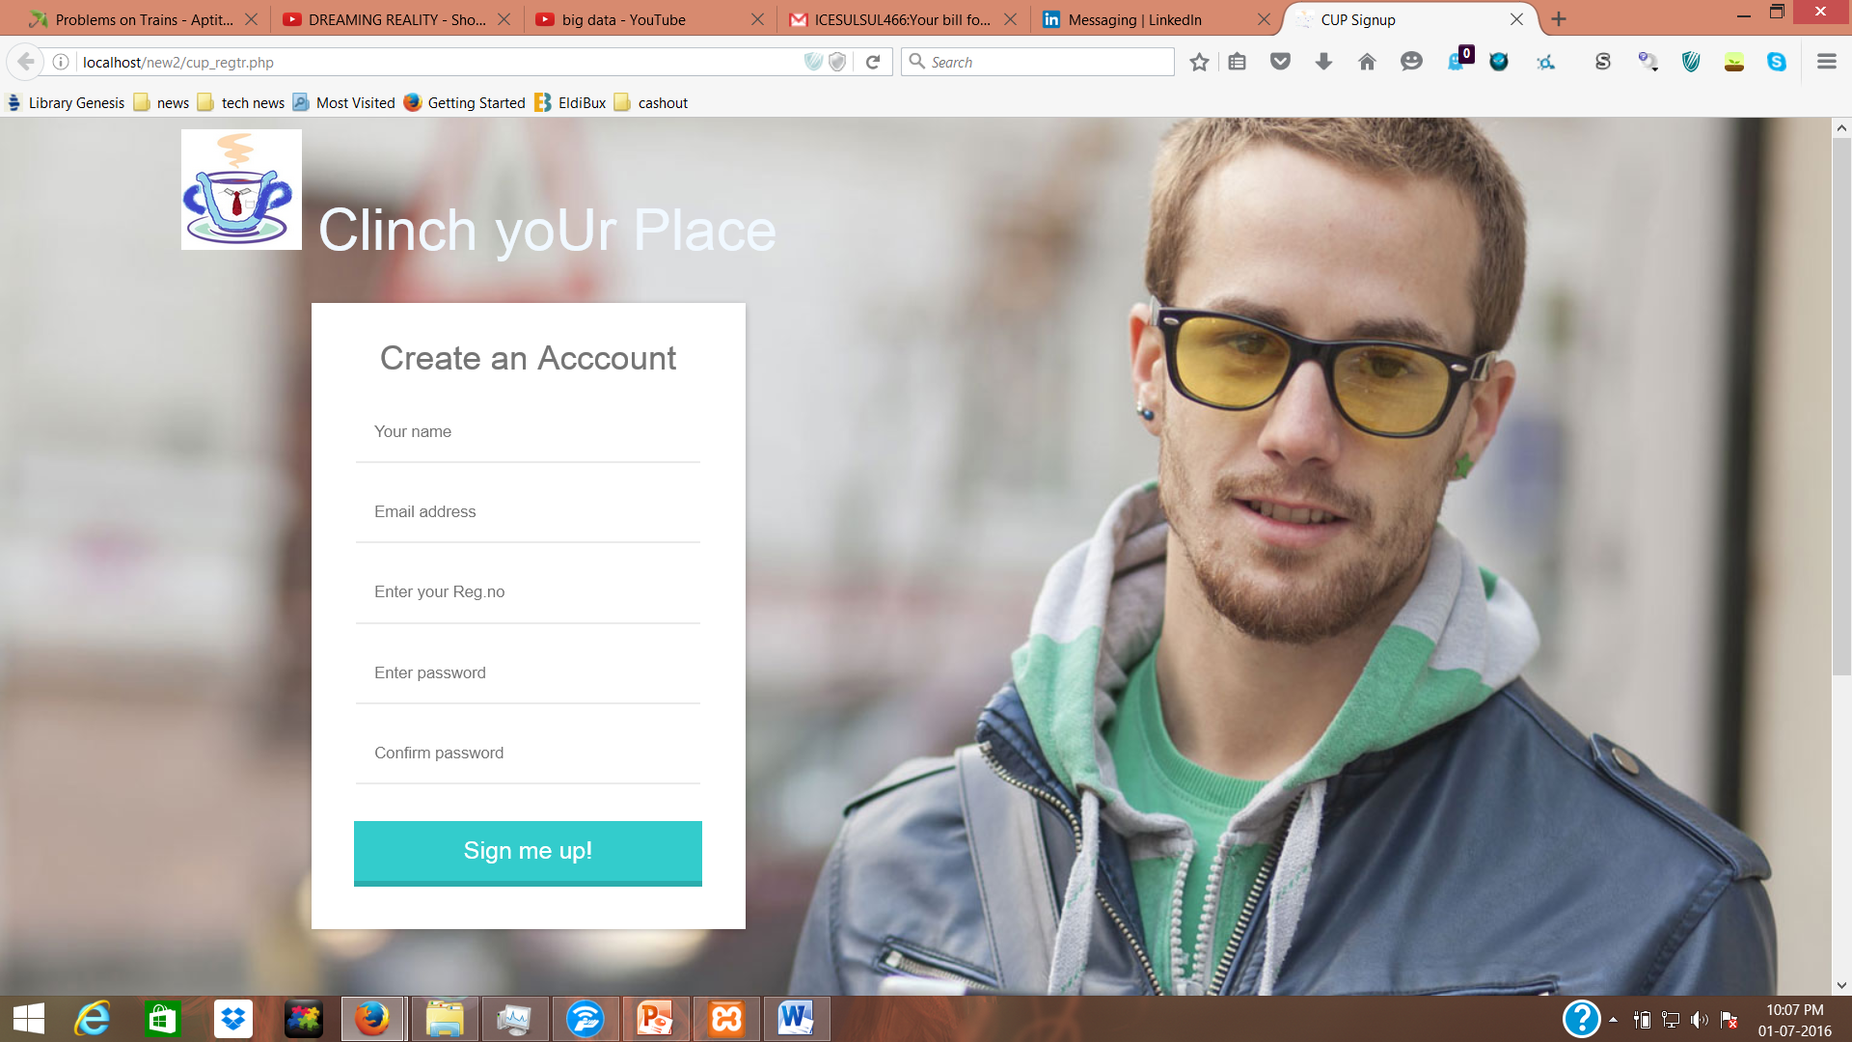

Login :

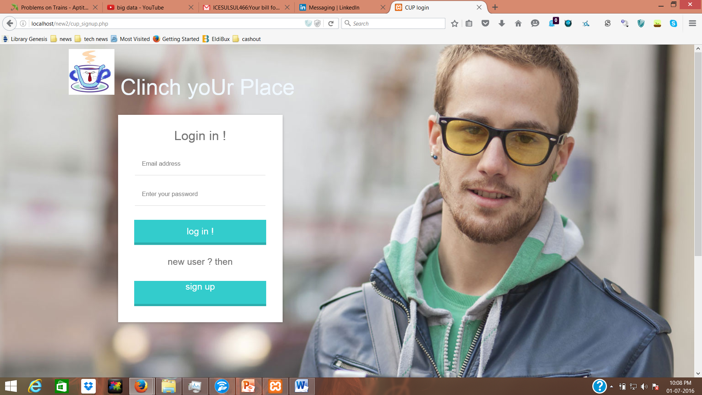

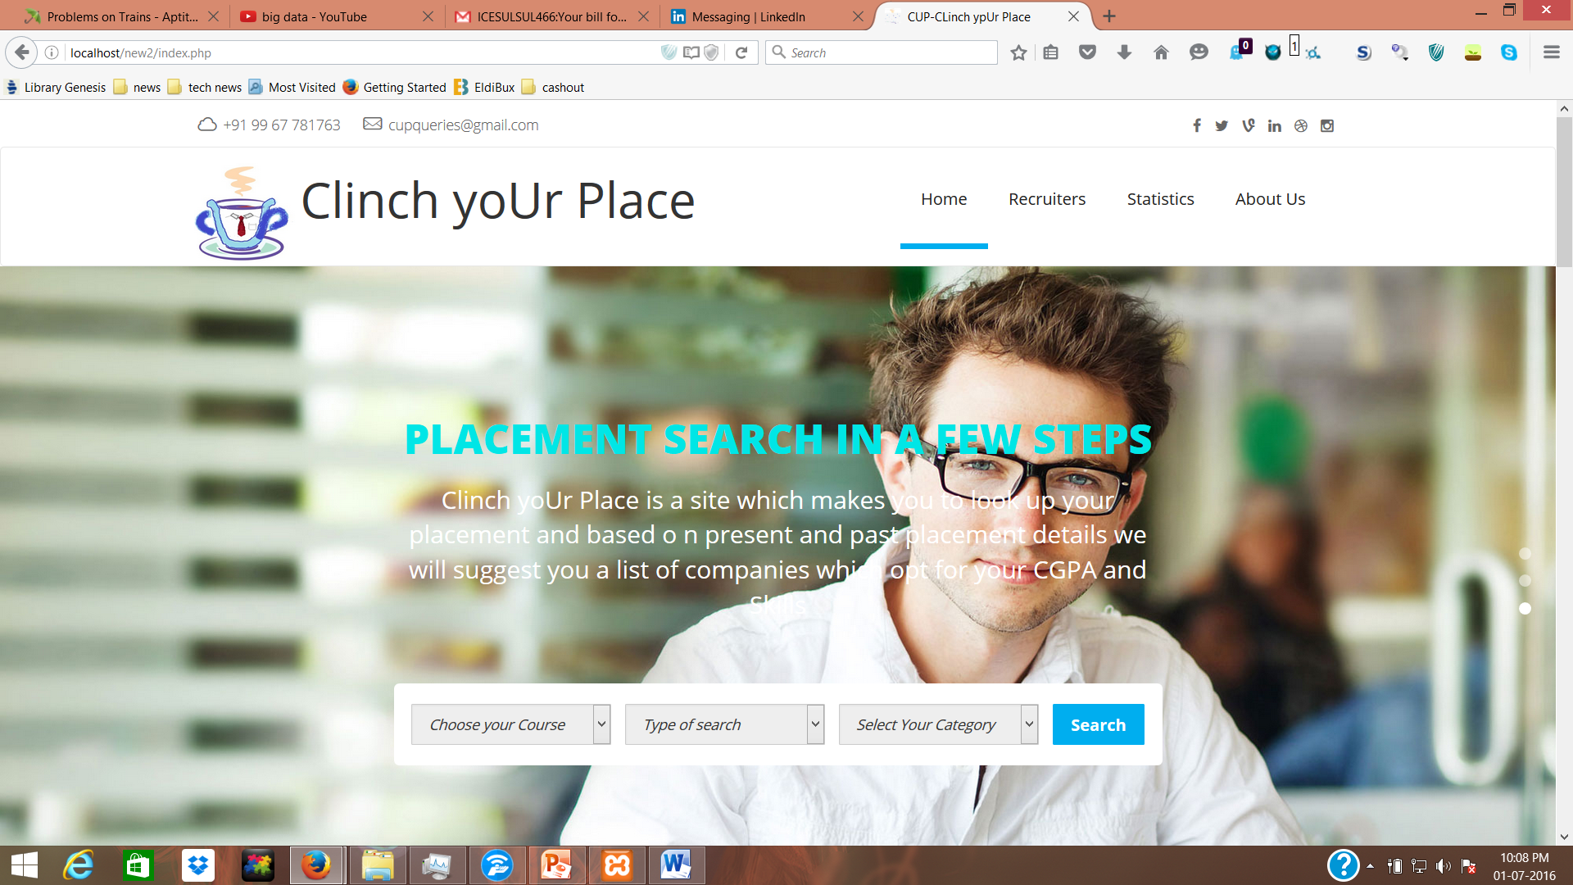

Skill basedsearch :

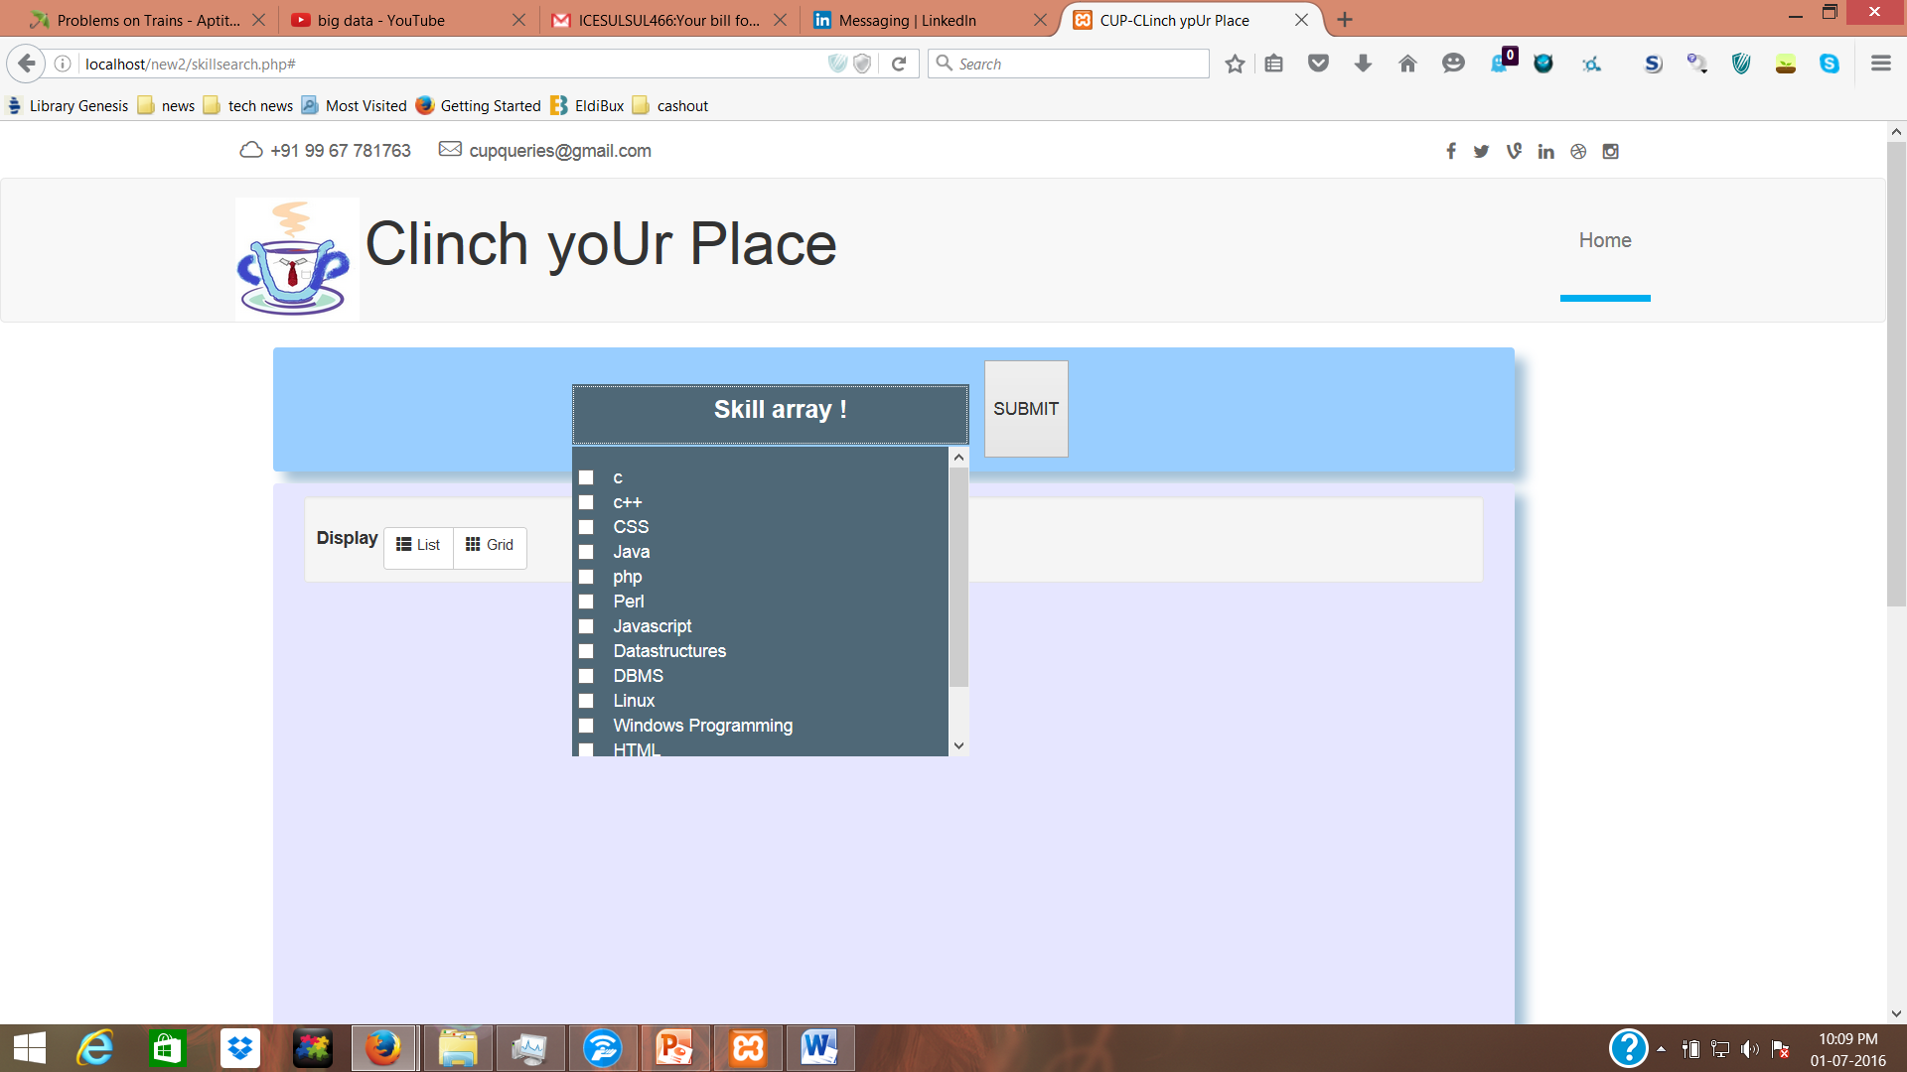

Cgpabased search :

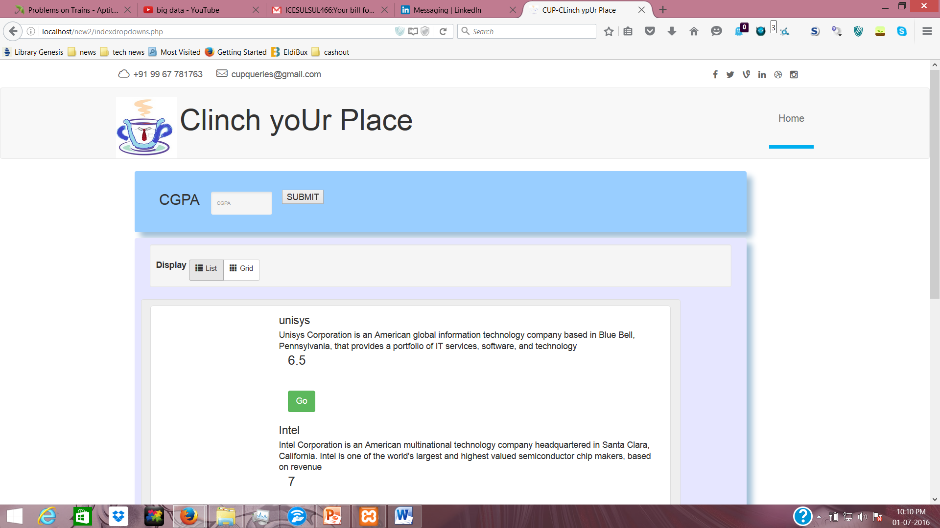

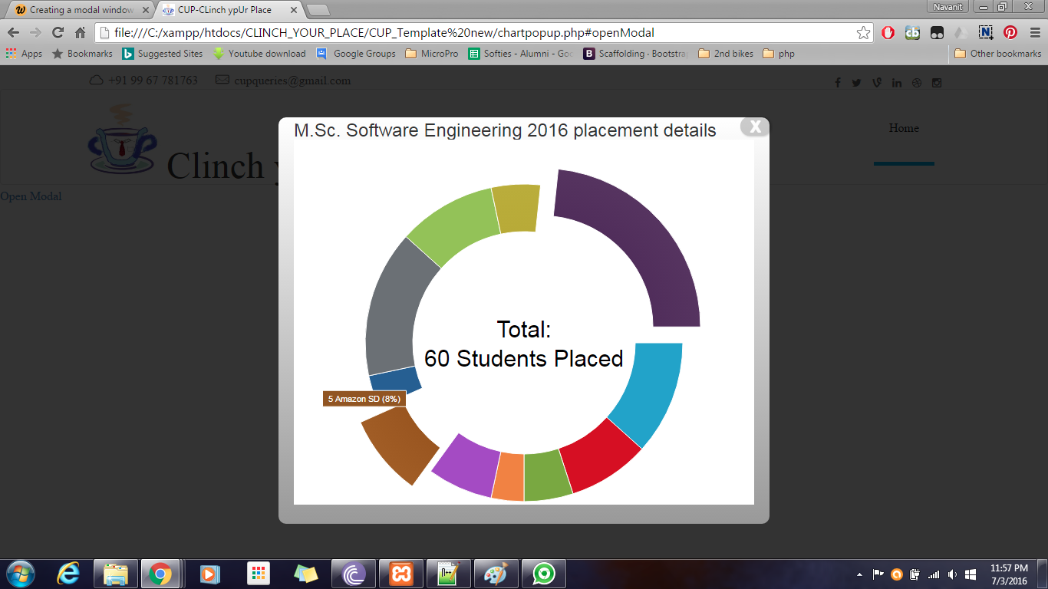

Statistics:

Question template :

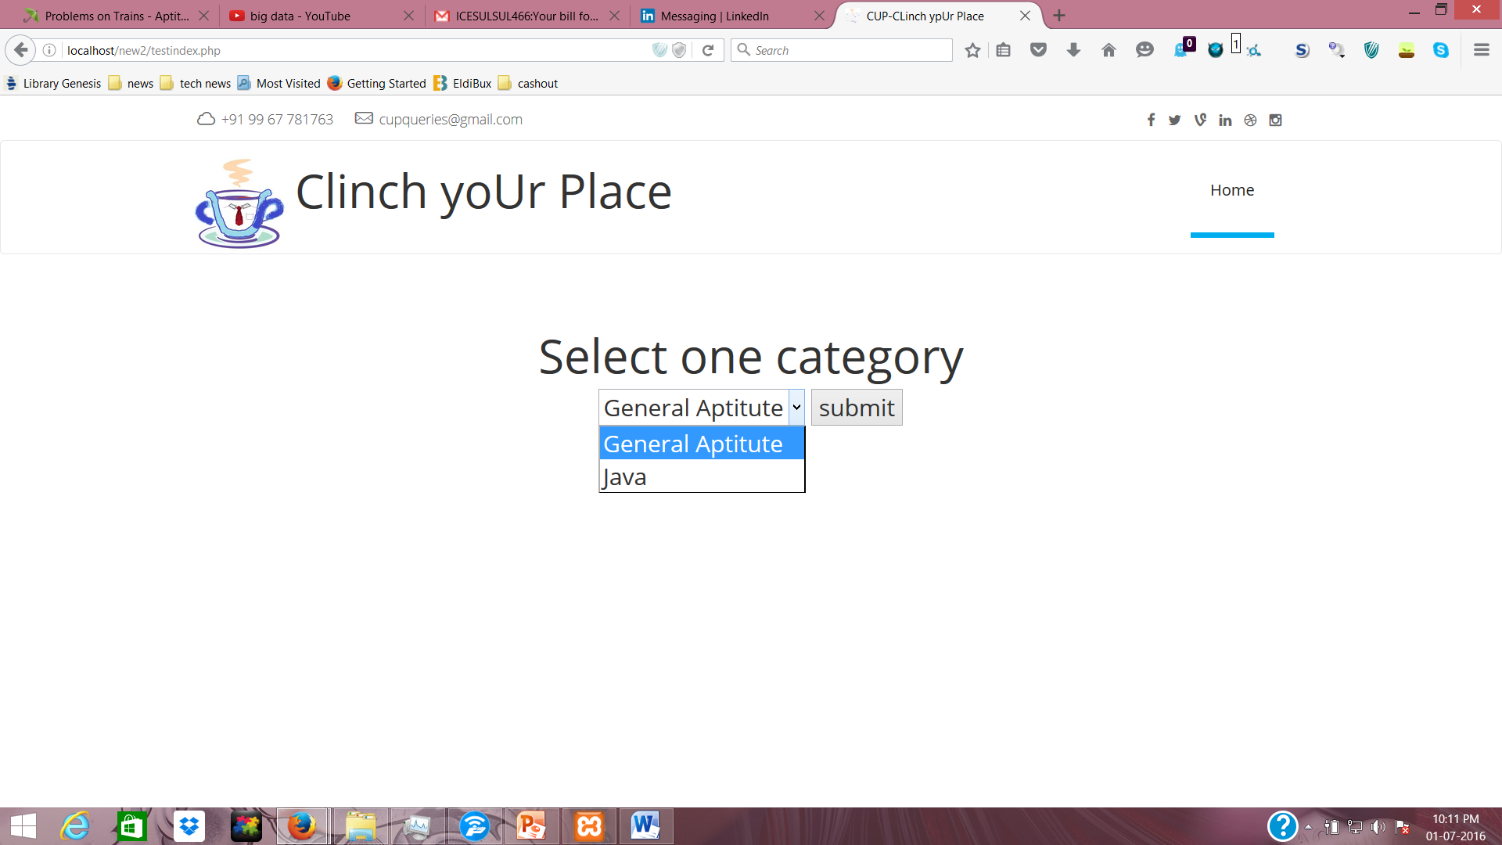

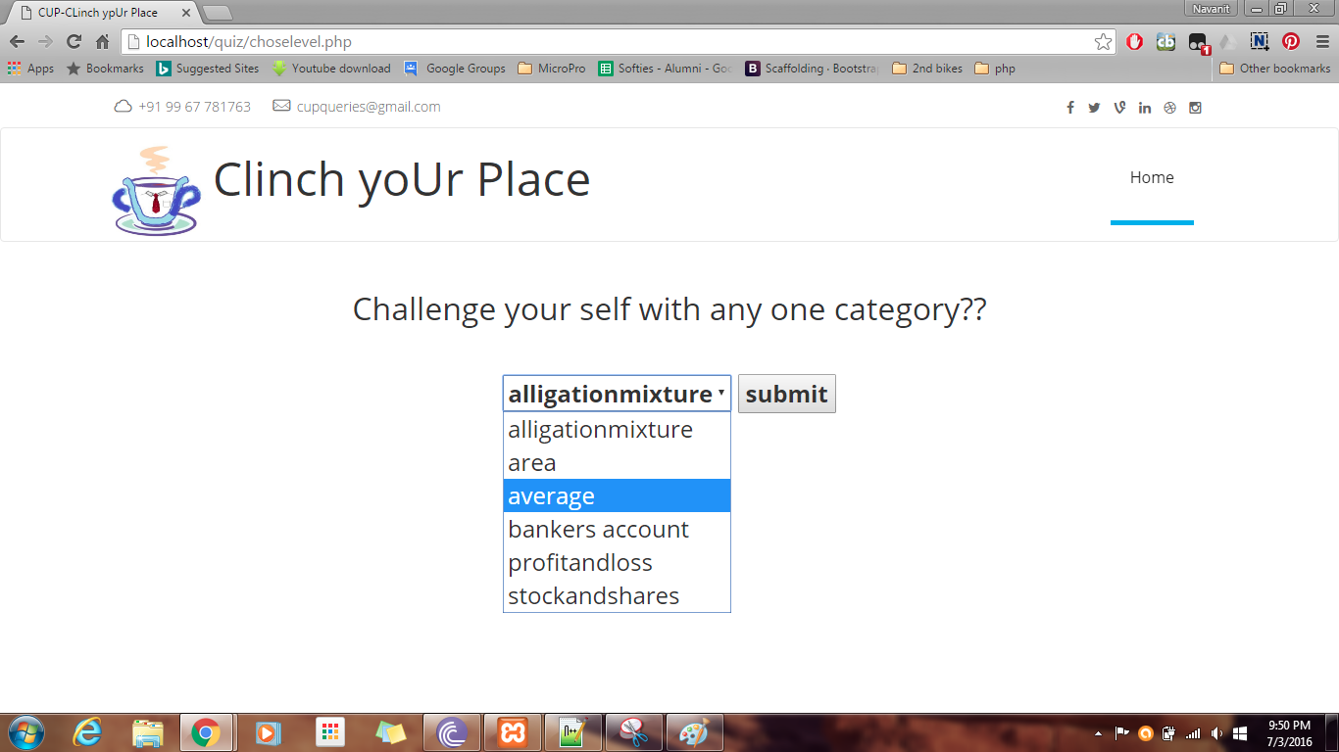

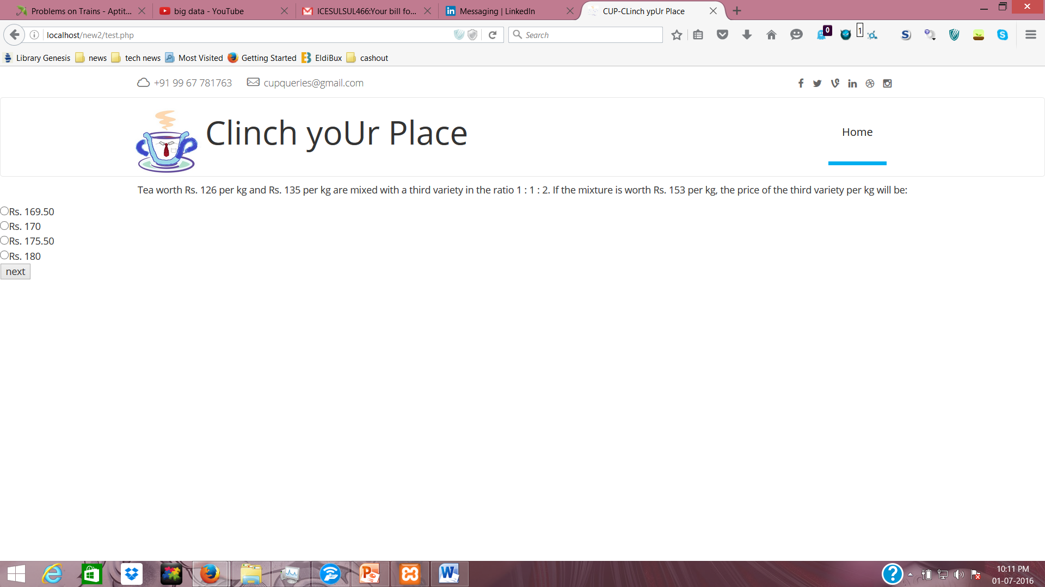

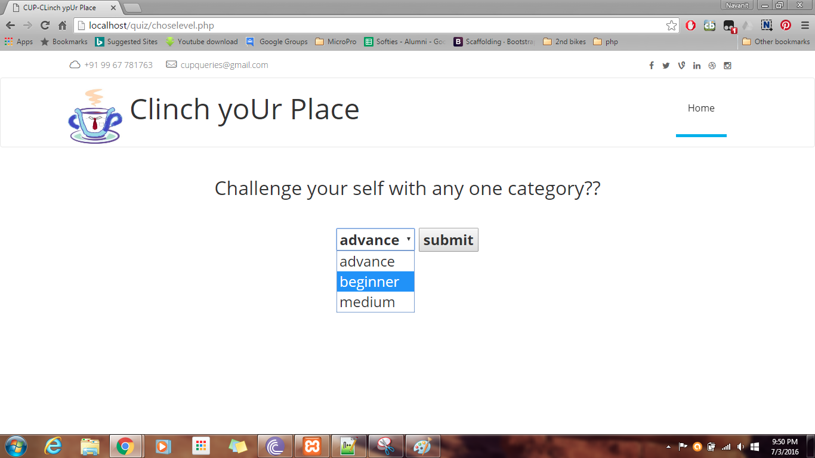

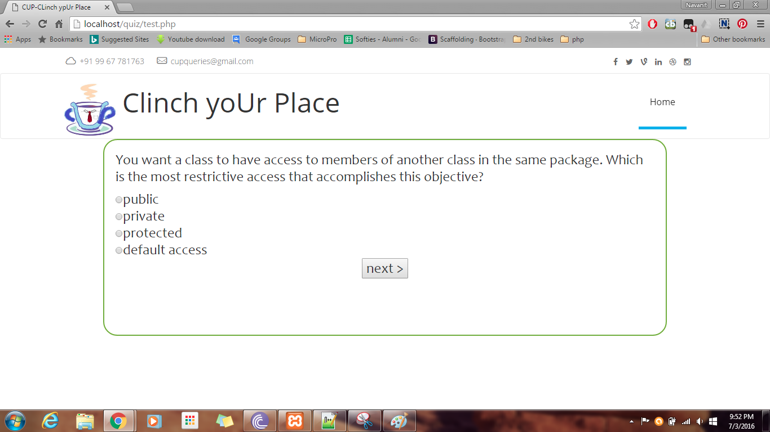

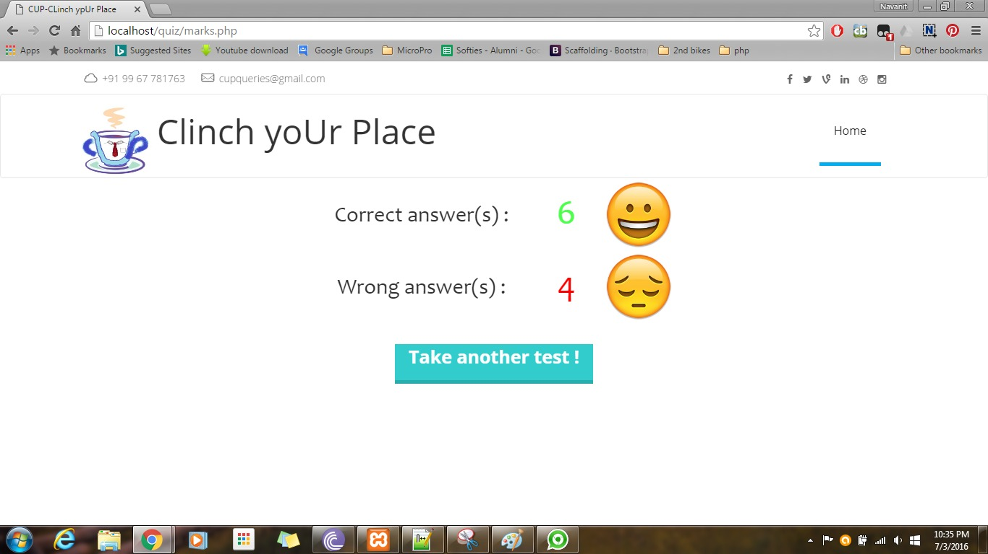

Database:

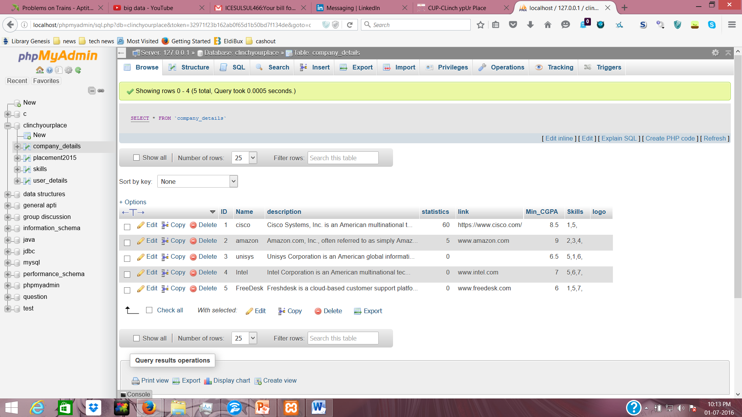

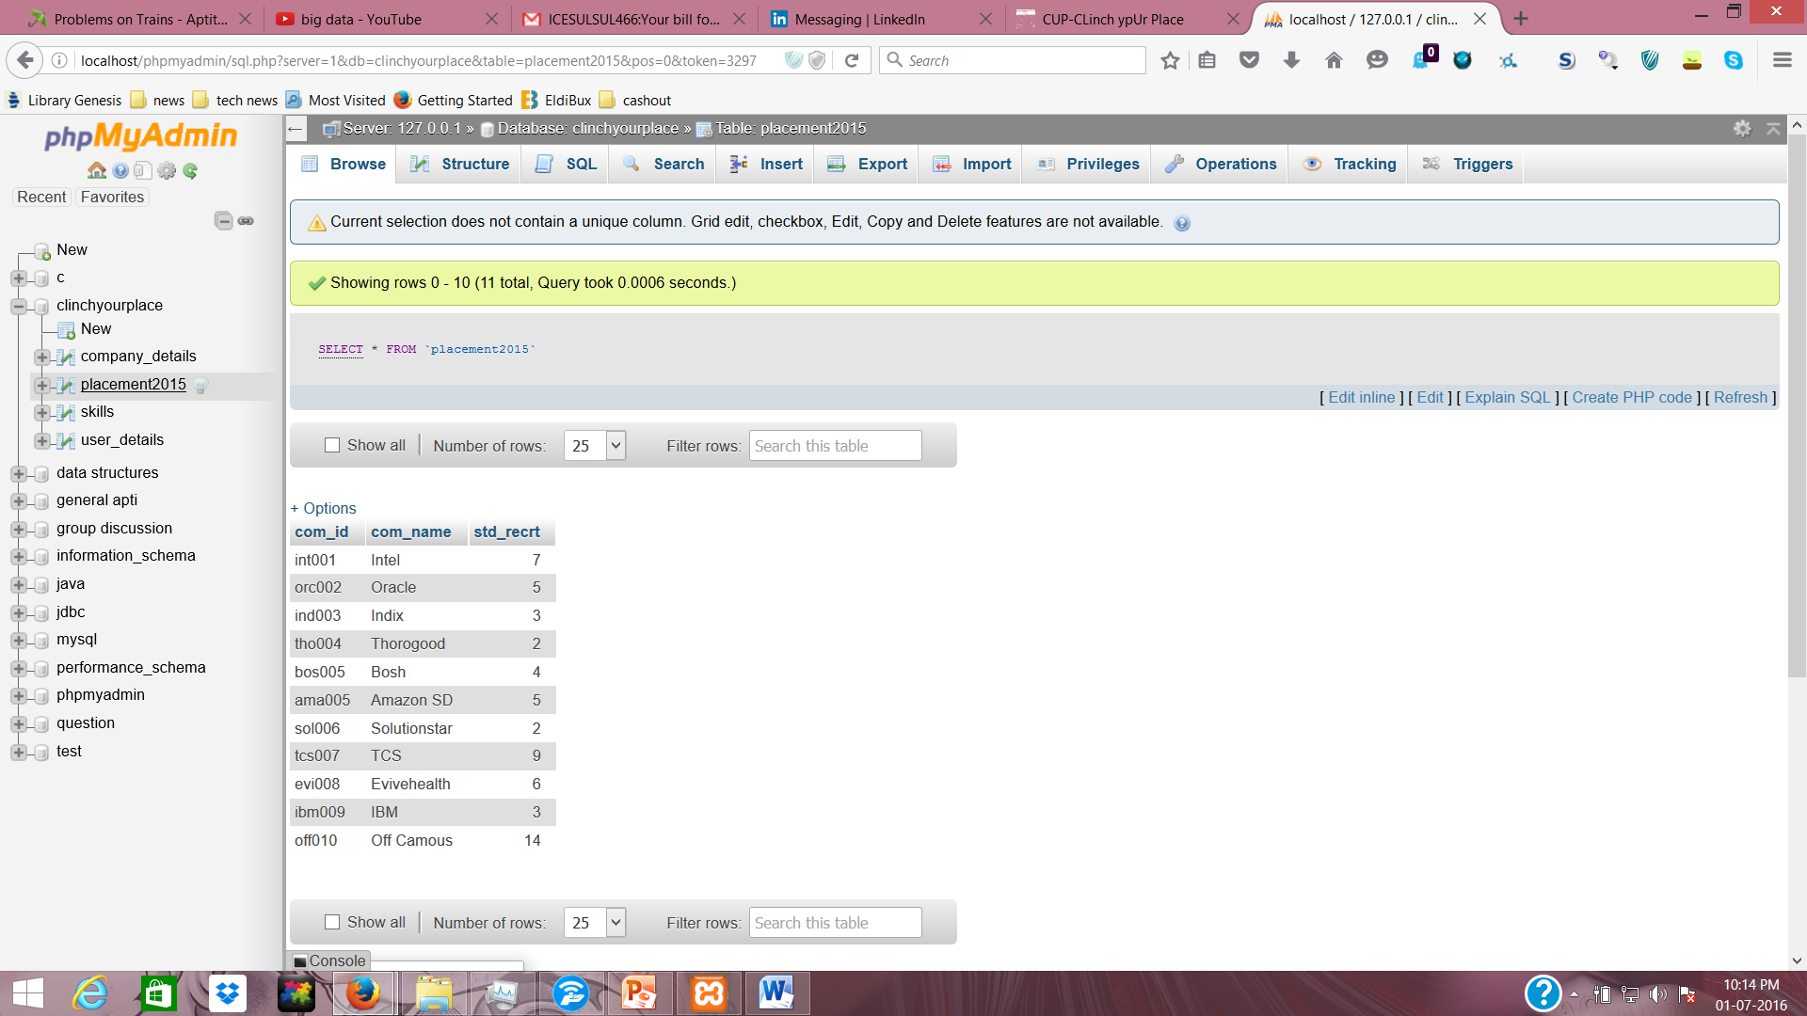

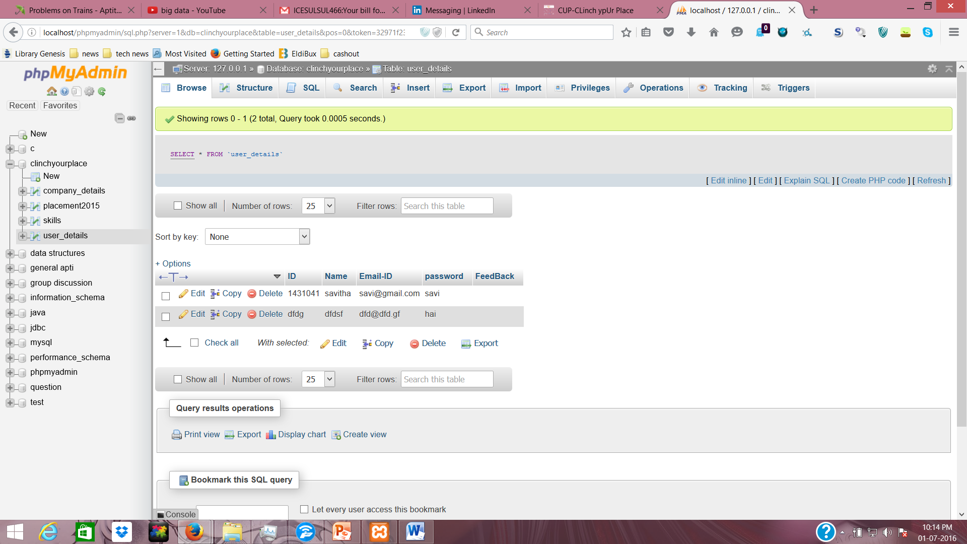

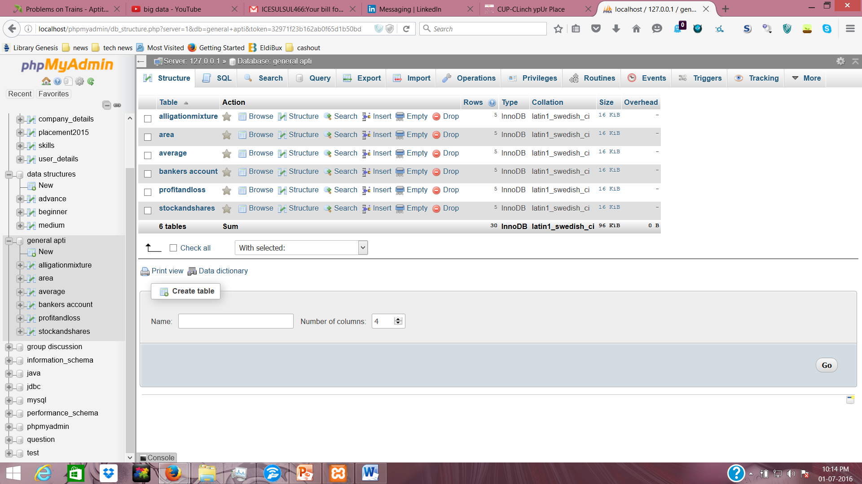

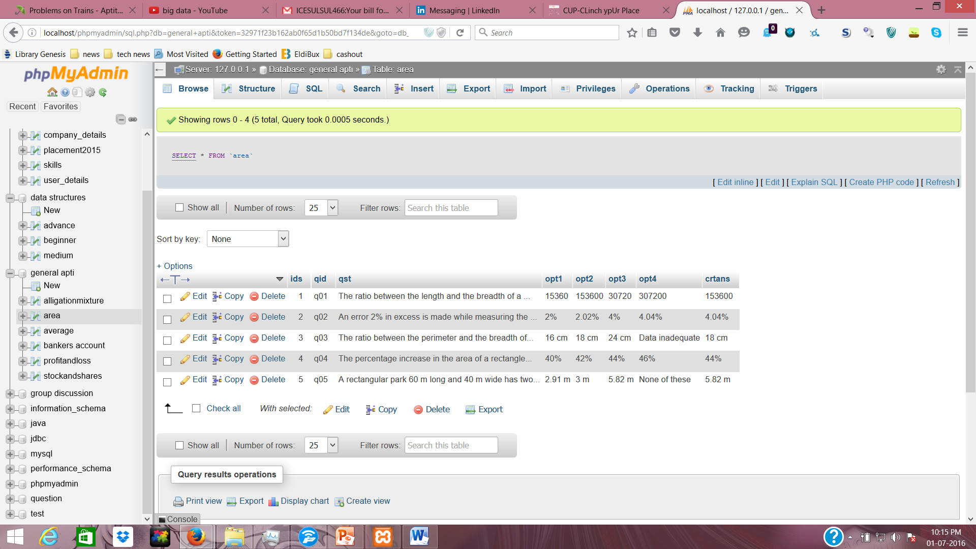

CODING:

Home :

<!DOCTYPE html>

<!--[if lt IE 7]><html class="no-js lt-ie9 lt-ie8 lt-ie7"><![endif]-->

<!--[if IE 7]><html class="no-js lt-ie9 lt-ie8"><![endif]-->

<!--[if IE 8]><html class="no-js lt-ie9"><![endif]-->

<!--[if gt IE 8]><!--><html class="no-js"><!--<![endif]-->

<head>

<meta charset="utf-8">

<meta http-equiv="X-UA-Compatible" content="IE=edge">

<title>CUP-CLinchypUr Place </title>

<meta name="description" content="company is a free job board template">

<meta name="author" content="Ohidul">

<meta name="keyword" content="html, css, bootstrap, job-board">

<meta name="viewport" content="width=device-width, initial-scale=1">

<link href='http://fonts.googleapis.com/css?family=Open+Sans:400,300,700,800' rel='stylesheet' type='text/css'>

<!-- Place favicon.ico and apple-touch-icon.png in the root directory -->

<linkrel="shortcut icon" href="favicon.ico" type="image/x-icon">

<linkrel="icon" href="img/cup_logo_ico.ico" type="image/x-icon">

<linkrel="stylesheet" href="css/normalize.css">

<linkrel="stylesheet" href="css/font-awesome.min.css">

<linkrel="stylesheet" href="css/fontello.css">

<linkrel="stylesheet" href="css/animate.css">

<linkrel="stylesheet" href="css/bootstrap.min.css">

<linkrel="stylesheet" href="css/owl.carousel.css">

<linkrel="stylesheet" href="css/owl.theme.css">

<linkrel="stylesheet" href="css/owl.transitions.css">

<linkrel="stylesheet" href="style.css">

<linkrel="stylesheet" href="responsive.css">

<scriptsrc="js/vendor/modernizr-2.6.2.min.js"></script>

</head>

<body>

<div id="preloader" >

<div id="status"><imgsrc="img/Cup_logo1.jpg"></div>

</div>

<!-- Body content -->

<div class="header-connect" id="header-connect">

<div class="container">

<div class="row">

<div class="col-md-5 col-sm-8 col-xs-8">

<div class="header-half header-call">

<p>

<span><i class="icon-cloud"></i>+91 99 67 781763</span>

<span><i class="icon-mail"></i>cupqueries@gmail.com</span>

</p>

</div>

</div>

<div class="col-md-2 col-md-offset-5 col-sm-3 col-sm-offset-1 col-xs-3 col-xs-offset-1">

<div class="header-half header-social">

<ul class="list-inline">

<li><a href="#"><i class="fafa-facebook"></i></a></li>

<li><a href="#"><i class="fafa-twitter"></i></a></li>

<li><a href="#"><i class="fafa-vine"></i></a></li>

<li><a href="#"><i class="fafa-linkedin"></i></a></li>

<li><a href="#"><i class="fafa-dribbble"></i></a></li>

<li><a href="#"><i class="fafa-instagram"></i></a></li>

</ul>

</div>

</div>

</div>

</div>

</div>

<nav class="navbarnavbar-default">

<div class="container">

<!-- Brand and toggle get grouped for better mobile display -->

<div class="navbar-header">

<button type="button" class="navbar-toggle collapsed" data-toggle="collapse" data-target="#bs-example-navbar-collapse-1">

<span class="sr-only">Toggle navigation</span>

<span class="icon-bar"></span>

<span class="icon-bar"></span>

<span class="icon-bar"></span>

</button>

<imgsrc="img/Cup_logo1.jpg" width = "100px" height = "100px" alt="">

<font size ="150%" >Clinch yoUr Place </font>

<!--<font size = "6px" color ="black">C</font>

linchyo

<font size = "6px" color ="black">U</font>

r<font size = "6px" color ="black">

P</font>

lace</a>-->

</div>

<!-- Collect the nav links, forms, and other content for toggling -->

<div class="collapse navbar-collapse" id="bs-example-navbar-collapse-1">

<!--<div class="button navbar-right">

<button class="navbar-btnnav-button wow bounceInRight login" data-wow-delay="0.8s">Login</button>

<button class="navbar-btnnav-button wow fadeInRight" data-wow-delay="0.6s">Sign up</button>

</div>-->

<ul class="main-navnavnavbar-navnavbar-right">

<li class="wow fadeInDown" data-wow-delay="0s"><a class="active" href="#">Home</a></li>

<li class="wow fadeInDown" data-wow-delay="0.1s"><a href="#container">Recruiters </a></li>

<li class="wow fadeInDown" data-wow-delay="0.2s"><a href="statistics.php">Statistics</a></li>

<li class="wow fadeInDown" data-wow-delay="0.3s"><a href="#content-area">About us</a></li>

<!--<li class="wow fadeInDown" data-wow-delay="0.4s"><a href="#">Blog</a></li>-->

</ul>

</div><!-- /.navbar-collapse -->

</div><!-- /.container-fluid -->

</nav>

<div class="slider-area">

<div class="slider">

<div id="bg-slider" class="owl-carousel owl-theme">

<div class="item"><imgsrc="img/slider-image-3.jpg" alt="Mirror Edge"></div>

<div class="item"><imgsrc="img/slider-image-2.jpg" alt="The Last of us"></div>

<div class="item"><imgsrc="img/slider-image-1.jpg" alt="GTA V"></div>

</div>

</div>

<div class="container slider-content">

<div class="row">

<div class="col-lg-8 col-lg-offset-2 col-md-10 col-md-offset-1 col-sm-12">

<h2 class = "center_title">Placement search in a few steps </h2>

<p class ="slider_text"><font size ="5px" color = "#fff">Clinch yoUr Place is a site which makes you to look up your placement and based o

n present and past placement details we will suggest you a list of companies which opt for your CGPA and Skills</font></p>

<div class="search-form wow pulse" data-wow-delay="0.8s">

<form action="<?php echo $_SERVER['PHP_SELF'];?>" method="post" class=" form-inline">

<!--<div class="form-group">

<input type="text" class="form-control" placeholder="">

</div>-->

<div class="form-group">

<select name="course" id="" class="form-control">

<option>Choose your Course</option>

<option>M.Sc Software Systems</option>

<option>B.Sc CSD</option>

<option>b.Sc IS</option>

<option>MCA</option>

</select>

</div>

<div class="form-group">

<select name="sear" id="sear" class="form-control">

<option>Type of search</option>

<option>CGPA</option>

<option>Skill</option>

</select>

</div>

<div class="form-group">

<select name="cat" id="" class="form-control">

<option>Select Your Category</option>

<option>Internship</option>

<option>Final Placements</option>

</select>

</div>

<input type="submit" name="submit" class="btn" value="Search">

</form>

</div>

</div>

</div>

</div>

</div>

<?php if(isset($_POST['submit']))

{ if($_POST['sear']=="CGPA"){ echo "ho";?><script>window.location="http://localhost/new2/indexdropdowns.php" </script><?php }

if($_POST['sear']=="Skill"){ echo "ho";?><script>window.location="http://localhost/new2/skillsearch.php" </script><?php } }?>

<div id="content-area">

<div class="content-area">

<div class="container">

<div class="row page-title text-center wow zoomInDown" data-wow-delay="1s">

<h5>Our Process</h5>

<h2>How we work for you?</h2>

<p>Clinch yoUr Place is a site which makes you to look up your placement and based

on present and past placement details we will suggest you a list of companies which opt for your CGPA and Skills</p>

</div>

<div class="row how-it-work text-center">

<div class="col-md-4">

<div class="single-work wow fadeInUp" data-wow-delay="0.8s">

<imgsrc="img/how-work1.png" alt="">

<h3>#1 CGPA based</h3>

<p>Using the outcomes from the job, we will put together a plan for the most effective marketing strategy to get the best results.</p>

</div>

</div>

<div class="col-md-4">

<div class="single-work wow fadeInUp" data-wow-delay="0.9s">

<imgsrc="img/how-work2.png" alt="">

<h3>#2 SKILL based</h3>

<p>Using the outcomes from the job, we will put together a plan for the most effective marketing strategy to get the best results.</p>

</div>

</div>

<div class="col-md-4">

<div class="single-work wow fadeInUp" data-wow-delay="1s">

<imgsrc="img/how-work3.png" alt="">

<h3>#3 SKILL & CGPA based</h3>

<p>Using the outcomes from the job, we will put together a plan for the most effective marketing strategy to get the best results.</p>

</div>

</div>

</div>

</div>

</div><hr>

<!--

<div class="container">

<div class="row job-posting wow fadeInUp" data-wow-delay="1s">

<div role="tabpanel">

<ul class="navnav-tabs" role="tablist">

<li role="presentation" class="active"><a href="#job-seekers" aria-controls="home" role="tab" data-toggle="tab">Job Seekers</a></li>

<li role="presentation"><a href="#employeers" aria-controls="profile" role="tab" data-toggle="tab">Employeers</a></li>

</ul>

<div class="tab-content">

<div role="tabpanel" class="tab-pane fade in active" id="job-seekers">

<ul class="list-inline job-seeker">

<li>

<ahref="">

<imgsrc="img/team-small-5.jpg" alt="">

<div class="overlay"><h3>Ohidul Islam</h3><p>Web Designer</p></div>

</a>

</li>

<li>

<ahref="">

<imgsrc="img/team-small-6.jpg" alt="">

<div class="overlay"><h3>Mohidul Islam</h3><p>CEO</p></div>

</a>

</li>

<li>

<ahref="">

<imgsrc="img/team-small-3.jpg" alt="">

<div class="overlay"><h3>Unknown girl</h3><p>Graphic Designer</p></div>

</a>

</li>

<li>

<ahref="">

<imgsrc="img/team-small-4.jpg" alt="">

<div class="overlay"><h3>EftakherAlam</h3><p>Graphic Designer</p></div>

</a>

</li>

<li>

<ahref="">

<imgsrc="img/team-small-2.jpg" alt="">

<div class="overlay"><h3>Mark Otto</h3><p>Founder</p></div>

</a>

</li>

<li>

<ahref="">

<imgsrc="img/team-small-1.jpg" alt="">

<div class="overlay"><h3>Rasel Ahmed</h3><p>Web Developer</p></div>

</a>

</li>

</ul>

</div>

<div role="tabpanel" class="tab-pane fade" id="employeers">

<ul class="list-inline">

<li>

<ahref="">

<imgsrc="img/employee4.png" alt="">

<div class="overlay"><h3>Instagram</h3></div>

</a>

</li>

<li>

<ahref="">

<imgsrc="img/employee5.png" alt="">

<div class="overlay"><h3>Microsoft</h3></div>

</a>

</li>

<li>

<ahref="">

<imgsrc="img/employee6.png" alt="">

<div class="overlay"><h3>Dribbble</h3></div>

</a>

</li>

<li>

<ahref="">

<imgsrc="img/employee1.png" alt="">

<div class="overlay"><h3>Beats Music</h3></div>

</a>

</li>

<li>

<ahref="">

<imgsrc="img/employee2.png" alt="">

<div class="overlay"><h3>Facebook</h3></div>

</a>

</li>

<li>

<ahref="">

<imgsrc="img/employee3.png" alt="">

<div class="overlay"><h3>Twitter</h3></div>

</a>

</li>

</ul>

</div>

</div>

</div>

</div>

</div>

<hr>

-->

<div class="container" id="container">

<div class="row page-title text-center wow bounce" data-wow-delay="1s">

<h5>Recent recruiters</h5>

<h2><span>20+</span> Available recruiters for you</h2>

</div>

<div class="row jobs">

<div class="col-md-9">

<div class="job-posts table-responsive">

<table class="table">

<tr class="odd wow fadeInUp" data-wow-delay="1s">

<td class="tbl-logo"><imgsrc="img/oracle.png" class ="comp_logo" alt="" height = "50px" width="100px"></td>

<td class="tbl-title"><h4>Oracle<br></h4></td>

<td class="tbl-apply"><a href="#">View</a></td>

</tr>

<tr class="even wow fadeInUp" data-wow-delay="1.1s">

<td class="tbl-logo"><imgsrc="img/ibm.jpg" class ="comp_logo" alt="" height = "50px" width="100px"></td>

<td class="tbl-title"><h4>IBM <br></h4></td>

<td class="tbl-apply"><a href="#">View</a></td>

</tr>

<tr class="odd wow fadeInUp" data-wow-delay="1.2s">

<td class="tbl-logo"><imgsrc="img/microsoft.png" class ="comp_logo" alt=""height = "50px" width="100px"></td>

<td class="tbl-title"><h4>Microsoft<br></h4></td>

<td class="tbl-apply"><a href="#">View</a></td>

</tr>

<tr class="even wow fadeInUp" data-wow-delay="1.3s">

<td class="tbl-logo"><imgsrc="img/amazon.png" class ="comp_logo" alt="" height = "50px" width="100px"></td>

<td class="tbl-title"><h4>Amazon <br></h4></td>

<td class="tbl-apply"><a href="#">View</a></td>

</tr>

<tr class="odd wow fadeInUp" data-wow-delay="1.4s">

<td class="tbl-logo"><imgsrc="img/intel.png" class ="comp_logo" alt="" height = "50px" width="100px"></td>

<td class="tbl-title"><h4>Intel <br></h4></td>

<td class="tbl-apply"><a href="#">View</a></td>

</tr>

<tr class="even hide-jobs">

<td class="tbl-logo"><imgsrc="img/digiapp.png" class ="comp_logo" alt="" height = "50px" width="100px"></td>

<td class="tbl-title"><h4>Digiapp<br></h4></td>

<td class="tbl-apply"><a href="#">View</a></td>

</tr>

<tr class="odd hide-jobs">

<td class="tbl-logo"><imgsrc="img/thorogood.jpg" class ="comp_logo" alt="" height = "50px" width="100px"</td>

<td class="tbl-title"><h4>Thorogood<br></h4></td>

<td class="tbl-apply"><a href="#">View</a></td>

</tr>

<tr class="even hide-jobs">

<td class="tbl-logo"><imgsrc="img/microsoft.png" class ="comp_logo" alt="" height = "50px" width="100px"></td>

<td class="tbl-title"><h4>Microsoft <br></h4></td>

<td class="tbl-apply"><a href="#">View</a></td>

</tr>

<tr class="odd hide-jobs">

<td class="tbl-logo"><imgsrc="img/job-logo5.png" class ="comp_logo" alt="" height = "50px" width="100px"></td>

<td class="tbl-title"><h4>Software Designer <br></h4></td>

<td class="tbl-apply"><a href="#">View</a></td>

</tr>

</table>

</div>

<div class="more-jobs">

<ahref=""><i class="fafa-refresh"></i>View more companies</a>

</div>

</div>

<div class="col-md-3 hidden-sm">

<div class="job-add wow fadeInRight" data-wow-delay="1.5s">

<h2><font size="5px">To know about placement?</font></h2>

</div>

</div>

</div>

</div>

<hr>

<div class="container">

<div class="row page-title text-center wow bounce" data-wow-delay=".7s">

<h5>TESTIMONIALS</h5>

<h2>WHAT PEOPLES ARE SAYING</h2>

</div>

<div class="row testimonial">

<div class="col-md-12">

<div id="testimonial-slider">

<div class="item">

<div class="client-text">

<p>Jobify offer an amazing service and I couldn’t be happier! They

are dedicated to helping recruiters find great candidates, wonderful service!</p>

<h4><strong>Ohidul Islam, </strong><i>Web Designer</i></h4>

</div>

<div class="client-face wow fadeInRight" data-wow-delay=".9s">

<imgsrc="img/client-face1.png" alt="">

</div>

</div>

<div class="item">

<div class="client-text">

<p>Jobify offer an amazing service and I couldn’t be happier! They

are dedicated to helping recruiters find great candidates, wonderful service!</p>

<h4><strong>Ohidul Islam, </strong><i>Web Designer</i></h4>

</div>

<div class="client-face">

<imgsrc="img/client-face2.png" alt="">

</div>

</div>

<div class="item">

<div class="client-text">

<p>Jobify offer an amazing service and I couldn’t be happier! They

are dedicated to helping recruiters find great candidates, wonderful service!</p>

<h4><strong>Ohidul Islam, </strong><i>Web Designer</i></h4>

</div>

<div class="client-face">

<imgsrc="img/client-face1.png" alt="">

</div>

</div>

<div class="item">

<div class="client-text">

<p>Jobify offer an amazing service and I couldn’t be happier! They

are dedicated to helping recruiters find great candidates, wonderful service!</p>

<h4><strong>Ohidul Islam, </strong><i>Web Designer</i></h4>

</div>

<div class="client-face">

<imgsrc="img/client-face2.png" alt="">

</div>

</div>

</div>

</div>

</div>

</div>

</div>

<div class="footer-area">

<div class="container">

<div class="row footer">

<div class="col-md-4">

<div class="single-footer">

<imgsrc="img/cup_logo1.jpg" alt="" height = "100px" width = "100px" data-wow-delay="1s"><br><font size ="150%" color = "white">Clinch yoUr Place </font>

<p></p>

</div>

</div>

<div class="col-md-4">

<div class="single-footer">

<!--<h4>Twitter update</h4>

<div class="twitter-updates">

<div class="single-tweets">

<h5>ABOUT 9 HOURS</h5>

<p><strong>AGOMeet Aldous</strong> - a Brave New World for #rails with more cohesion, less coupling and greater dev speed <a href="http://t.co/rsekglotzs">http://t.co/rsekglotzs</a></p>

</div>

<div class="single-tweets">

<h5>ABOUT 9 HOURS</h5>

<p><strong>AGOMeet Aldous</strong> - a Brave New World for #rails with more cohesion, less coupling and greater dev speed <a href="http://t.co/rsekglotzs">http://t.co/rsekglotzs</a></p>

</div>

</div>-->

</div>

</div>

&nbsp;&nbsp;&nbsp;&nbsp;&nbsp;&nbsp;&nbsp;&nbsp;&nbsp;&nbsp;&nbsp;&nbsp;&nbsp;&nbsp;&nbsp;&nbsp;

<div class ="foot">

<div class="col-md-4">

<div class="single-footer">

<h4>Useful lnks</h4>

<div class="footer-links">

<ul class="list-unstyled">

<li><a href="#header-connect">Home</a></li>

<li><a href="#container">Recruiters</a></li>

<li><a href="">Statistics</a></li>

<li><a href="">About us</a></li>

<li><a href="">Contact us</a></li>

</ul>

</div>

</div>

</div>

</div>

<div class="row footer-copy">

<p><span>(C) webstie, All rights reserved</span> | <span><a href="#"></a></span> | <span><a href="#"></a></span></p>

</div>

</div>

</div>

<script src="http://ajax.googleapis.com/ajax/libs/jquery/1.10.2/jquery.min.js"></script>

<script>window.jQuery || document.write('<script src="js/vendor/jquery-1.10.2.min.js"><\/script>')</script>

<scriptsrc="js/bootstrap.min.js"></script>

<scriptsrc="js/owl.carousel.min.js"></script>

<scriptsrc="js/wow.js"></script>

<scriptsrc="js/main.js"></script>

</body>

</html>

cgpa based search :

<?php if(isset($_POST['submit'])){

$res=$_POST['cgpa'];

$result=mysql_query("SELECT * FROM `company_details` WHERE `Min_CGPA` <= $res ") or die("cannot select record<br>"); ?>

<div id="products" class="row list-group" >

<div class="item col-xs-4 col-lg-4" id="combox">

<div class="thumbnail">

<?php while($rows=mysql_fetch_array($result)) { ?>

<img class="group list-group-image" src="<?php echo $rows["logo"]; ?>" alt="" />

<div class="caption">

<h4 class="group inner list-group-item-heading">

<?php echo $rows["Name"] ; ?></h4>

<p class="group inner list-group-item-text">

<?php echo $rows["description"]; ?></p>

<div class="row">

<div class="col-xs-12 col-md-6">

<p class="lead">

<?php echo $rows["Min_CGPA"]; ?></p>

</div>

<div class="col-xs-12 col-md-6">

<a class="btnbtn-success" href="">Go</a>

</div>

</div>

</div>

<?php } } ?>

</div>

Skill based :

<div class="mutliSelect">

<ul>

<li>

&nbsp;&nbsp;&nbsp;&nbsp;<input type="checkbox" id="skill" name="check[]" value="1" />c</li>

<li>

&nbsp;&nbsp;&nbsp;&nbsp;<input type="checkbox" value="2" id="skill" name="check[]"/>c++</li>

<li>

&nbsp;&nbsp;&nbsp;&nbsp;<input type="checkbox" value="3"id="skill" name="check[]" />CSS</li>

<li>

&nbsp;&nbsp;&nbsp;&nbsp;<input type="checkbox" value="4" id="skill" name="check[]"/>Java</li>

<li>

&nbsp;&nbsp;&nbsp;&nbsp;<input type="checkbox" value="5" id="skill" name="check[]"/>php</li>

<li>

&nbsp;&nbsp;&nbsp;&nbsp;<input type="checkbox" value="6" id="skill" name="check[]"/>Perl</li>

<li>

&nbsp;&nbsp;&nbsp;&nbsp;<input type="checkbox" value="7" id="skill" name="check[]"/>Javascript</li>

<li>

&nbsp;&nbsp;&nbsp;&nbsp;<input type="checkbox" value="8" id="skill" name="check[]"/>Datastructures</li>

<li>

&nbsp;&nbsp;&nbsp;&nbsp;<input type="checkbox" value="9" id="skill" name="check[]"/>DBMS</li>

<li>

&nbsp;&nbsp;&nbsp;&nbsp;<input type="checkbox" value="10" id="skill" name="check[]"/>Linux</li>

<li>

&nbsp;&nbsp;&nbsp;&nbsp;<input type="checkbox" value="11" id="skill" name="check[]"/>Windows Programming</li>

<li>

&nbsp;&nbsp;&nbsp;&nbsp;<input type="checkbox" value="12" id="skill" name="check[]"/>HTML</li>

<li>

&nbsp;&nbsp;&nbsp;&nbsp;<input type="checkbox" value="13" id="skill" name="check[]"/>Angular JS</li>

<li>

&nbsp;&nbsp;&nbsp;&nbsp;<input type="checkbox" value="14" id="skill" name="check[]"/>.Net</li>

</ul>

</div>

</dd>

</center>

</dl>

&nbsp;&nbsp;&nbsp;<br>

<input type ="submit" name="submit" value="SUBMIT"></input>

<script src='http://cdnjs.cloudflare.com/ajax/libs/jquery/2.1.3/jquery.min.js'></script>

<scriptsrc="js/index.js"></script>

</div>

<div id="leftside">

</div>

<div id="result">

<div class="container">

<div class="well well-sm">

<strong>Display</strong>

<div class="btn-group">

<ahref="#" id="list" class="btnbtn-default btn-sm"><span class="glyphiconglyphicon-th-list">

</span>List</a><a href="#" id="grid" class="btnbtn-default btn-sm"><span

class="glyphiconglyphicon-th"></span>Grid</a>

</div>

</div>

<?php if(isset($_POST['submit'])){

$str="";

$chosen=$_POST['check'];

$f=0;

foreach ($chosen as $res){

if($f==0){$a=$res ; $f++;}

$str.=$res.",";

}

$result=mysql_query("SELECT * FROM `company_details` WHERE `Skills` like '$a%' OR `Skills` like '%$str%' ") ;//or //die("cannot select record<br>");

?>

<div id="products" class="row list-group" >

<div class="item col-xs-4 col-lg-4" id="combox">

<div class="thumbnail">

<?php while($rows=mysql_fetch_array($result)) { ?>

<img class="group list-group-image" src="<?php echo $rows["logo"]; ?>" alt="" />

<div class="caption">

<h4 class="group inner list-group-item-heading">

<?php echo $rows["Name"] ; ?></h4>

<p class="group inner list-group-item-text">

<?php echo $rows["description"]; ?></p>

<div class="row">

<div class="col-xs-12 col-md-6">

<p class="lead">

<?php echo $rows["Min_CGPA"]; ?></p>

</div>

<div class="col-xs-12 col-md-6">

<a class="btnbtn-success" href="">Go</a>

</div>

</div>

</div>

<?php } } ?>

</div>

</div>

</div>

</div>

Mock test :

<?php

$_SESSION['tid']++;

$tid=$_SESSION['tid'];

$rs=mysql_query("select * from `$table` where ids = $tid")or die("roe");

$rows=mysql_fetch_array($rs);

?>

<div class="qtn">

<p><center><?php echo $rows["qst"]; ?></center></p>

</div>

<div class="answ" align="left">

<input type="radio" id="answ" name="ans" value="<?php echo $rows["opt1"]; ?>" /><?php echo $rows["opt1"]; ?><br>

<input type="radio" id="answ" name="ans" value="<?php echo $rows["opt2"]; ?>" /><?php echo $rows["opt2"]; ?><br>

<input type="radio" id="answ" name="ans" value="<?php echo $rows["opt3"]; ?>" /><?php echo $rows["opt3"]; ?><br>

<input type="radio" id="answ" name="ans" value="<?php echo $rows["opt4"]; ?>" /><?php echo $rows["opt4"]; ?><br>

<input type="hidden" name="cans" value="<?php echo $rows["crtans"]; ?>" />

<?php if($_SESSION['tid'] < $max){

?>

<input type="submit" name="next" value="next"/><?php

if(isset($_POST['next'])){

if( $_POST['ans']== $_POST['cans']){

$_SESSION['right']++;

}

else {$_SESSION['wrong']++;}

}

}

else{

if( $_POST['ans']== $_POST['cans']){

$_SESSION['right']++;

}

else {$_SESSION['wrong']++;}

?><input type="submit" name="submit" value="submit" OnClick="dis()"/><?php

}

if(isset($_POST['submit'])){

?><script>window.location="http://localhost/new2/marks.php" </script><?php } ?>

</div>

CONCLUSION:

This website “clinch your place”, mainly focused on student’s placement helps them with easy search of companies . It also helps them to improve their skills. The next stage of our project will be the development of android application for our build-in website.